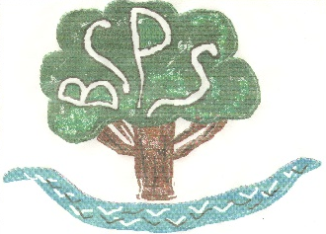

Bubwith Community Primary School Headteacher Recruitment Pack 2024-25

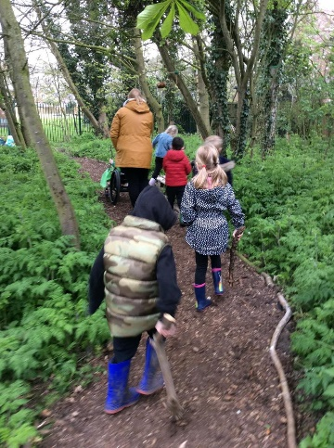
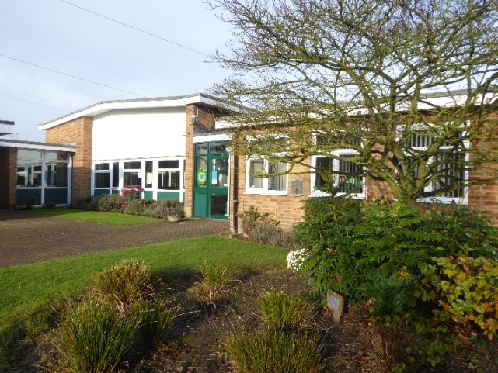

Believe, Challenge, Persevere, Succeed
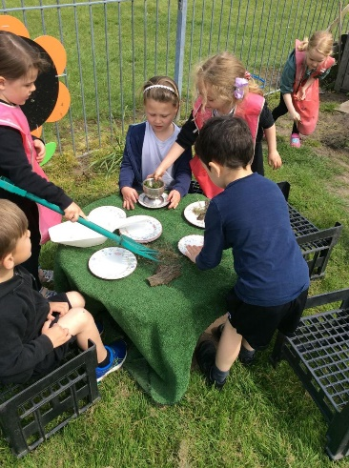
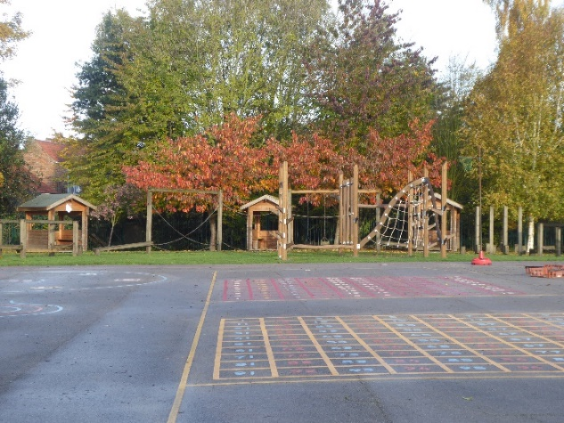




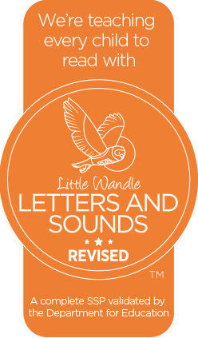

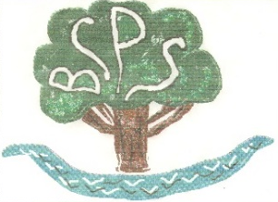


Believe, Challenge, Persevere, Succeed

A message from the co-chairs of the governing body
On behalf of all members of the school community, thank you for your interest in the post of headteacher at Bubwith Community Primary School. This is an exciting opportunity to lead a high achieving rural primary school at the heart of a thriving village. Our aim at Bubwith CPS is for all children to develop their talents, reach their potential and be safe and happy during their time with us. We are immensely proud of providing a curriculum and learning environment where children thrive and develop a love of learning.
The September 2024 Ofsted report was good in all areas. It stated that: ‘Pupils at Bubwith Community Primary School are happy. The school has high expectations for what pupils learn. This is realised and reflected in the school’s national tests and assessments. Pupils behave well in lessons and across the school. At breaktimes, pupils get on well together. Pupils know that the adults in the school will help them if they have any worries.’
Due to the resignation of the current headteacher, who is looking to follow a new career path, the school will be led by an interim headteacher in the spring term. The governing body is looking to appoint a new substantive headteacher for the start of the summer term 2025. The successful candidate will:
- Be a creative, reflective and inspirational leader who has children’s learning and emotional well-being at the heart of every decision
- Have the skills to lead, value, develop and manage a highly effective team with professionalism and respect, strongly supporting the development of skilled subject leaders
- Maintain high levels of behaviour and respect for others
- Continue our culture of high expectations of attainment and progress, initially focusing on improving writing across the school, extending the EYFs and KS1 outdoor learning provision and developing effective progression and assessment in the non-core curriculum
- Act as a role model as an outstanding practitioner, having an expected teaching commitment of up to 0.3 according to the needs of the school
- Be committed to providing a broad and balanced curriculum that stimulates a love of learning, encourages the development of individual talents, makes links to the world of work and introduces pupils to local, national and global issues
- Be approachable, building excellent relationships with children, staff, parents, governors and the wider community, publicising and celebrating the school’s successes and engaging with the interests and needs of local families so that the school has a sustainable future
- Promote extra-curricular provision and enrichment activities, including the development of the school grounds
I hope that these pages and our school website will give you all the information you need about this rewarding and challenging position. If you feel that you have the necessary attributes and are enthusiastic about joining us, then I encourage you to visit the school to see the staff and children at work on one of the times specified in the timetable. Please contact Lisa Baxter, our School Business Manager to arrange this at bubwith.primary@eastrding.gov.uk, or telephone 01757 288261.
Thank you again for your interest in Bubwith Community Primary School.
Emma Postlethwaite and Luke Howard
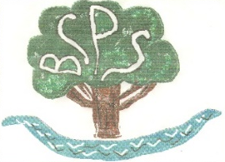
Recruitment Timetable
Visits to the school | 2pm or 4.15pm on 19th, 25th, 28th November, 4thDecember 2024
Closing date for applications | 12th December 2024, 3pm
Shortlisting | 17th December 2024
Interviews at the school | 15th and 16th January 2025
Governing body ratification | 16th January 2025
Start date | The summer term 2025

Starting salary: level 10 -12 (group one)

The school is committed to safeguarding and promoting the welfare and safety of children and young people and expects all staff to share this commitment. The successful candidate will be appointed subject to an Enhanced DBS check, appropriate qualifications and professional references.

Values, Aims and Ethos
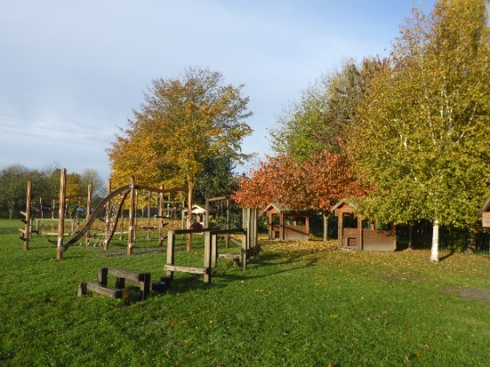
At Bubwith School we demonstrate the Bubwith Rights in all we do. Everyone at Bubwith has the right…
- To learn
- To feel and be safe
- To be treated with respect

We believe that education is a process through which we encourage the personal development of each child so that he/she will become a thinking adult who is able to appreciate and act upon the personal and social opportunities and responsibilities to be found in a changing society.
In order to fulfil the high expectations of our community, we aim:
1) To provide a caring, secure, stimulating environment where each child is supported and valued as an individual, enjoying success and encouraged to take risks.
2) To nurture every child's self-esteem and develop independence, while encouraging self-discipline, good manners and consideration for other people and their property.
3) To provide a broad, balanced and relevant curriculum that is appropriate for each individual child, as we seek to develop his / her full potential.
4) To provide opportunities within the curriculum to develop and support the child physically, socially, morally and creatively.
5) To encourage the involvement of parents / carers and members of the wider community in school life to enhance learning opportunities for all pupils.
6) To develop children's awareness of our rural community and its place in the wider, diverse world and of the interdependence between its various village communities and the environment.

The school and surrounding area
Bubwith Community Primary School is a rural village school with 116 pupils on roll. The children are currently taught in five classes, which may be mixed or single age according to the numbers in each year group. The building is well maintained and airy, with a library and multi-purpose quiet room, out- door learning provision, play and sports areas. The building is accessible to wheelchair users. School meals are cooked on the premises. Pupils from the school participate in some sporting activities that are organised by the local cluster of schools and are keen to expand on these opportunities.
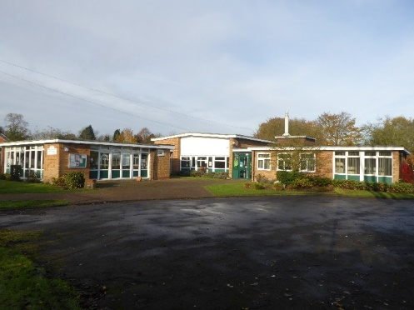
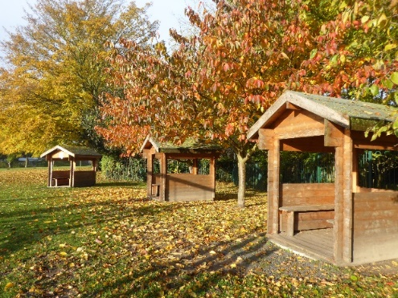

The school is located in the glorious East Riding countryside close to its border with North Yorkshire and within easy access of York, Selby, Beverley, Leeds and Hull. The children on roll come from the village of Bubwith itself and the many nearby villages and hamlets including Breighton, Foggathorpe, Laytham, Willitoft, Gribthorpe, Aughton, Ellerton and East Cottingwith which are served by school buses.
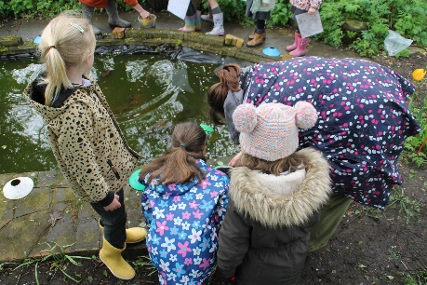
There is a highly effective and knowledgeable governing body that is actively involved in the school. The Friends of Bubwith School (FOBS) organises school social events and raises funds to provide equipment and enrichment activities for the benefit of our pupils e.g. creating two outstanding murals, running school discos, funding whole school theatre visits, library books, a stage and play equipment. They also run a pre-loved uniform shop. Parents and governors have transformed the school wild life area and run a weekly Eco Club for the pupils.
Pupils participate in the East Riding Big Sing and in sporting activities organised by the local cluster of schools. The school has established good links within the local community and continues to develop in this area. It enjoys close links with both the local catchment secondary school (Howden School) and the highly rated village Treehouse pre-school which has provision for children from 0 to 5 years and is located in a school classroom. A very popular breakfast club and after school club are also provided for pupils on the school premises.

Bubwith has a thriving tennis club, TV & film studios and a leisure centre which plays host to many events throughout the year including the most recent school harvest festival and a joint Macmillan coffee morning with the local church. There is a good relationship with the parish church which is approximately 100 metres from the school. The village also has an award winning delicatessen and an award winning butcher. There are many local walks by the river Derwent and along a scenic disused rail trail. Bubwith is on many cycle routes as it has been part of the Tour de Yorkshire.
Our curriculum extends beyond the National Curriculum. A range of enriching experiences and opportunities include after-school clubs and lunch clubs, specialist assemblies, whole school theme days and weeks, school visits /visitors.
The annual school residential at Peat Rigg outdoor education centre gives pupils the opportunity to develop their self-confidence, self-reliance and group collaboration skills in a safe and secure setting with great food!
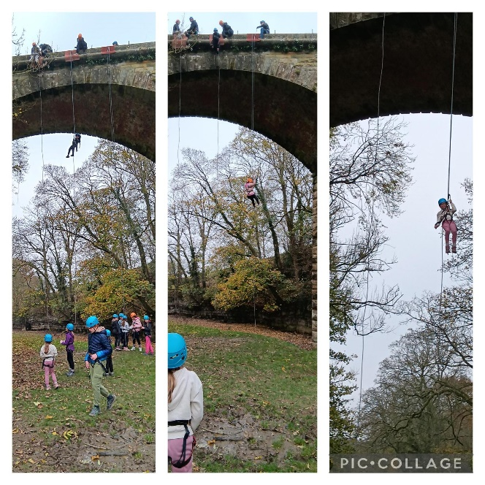
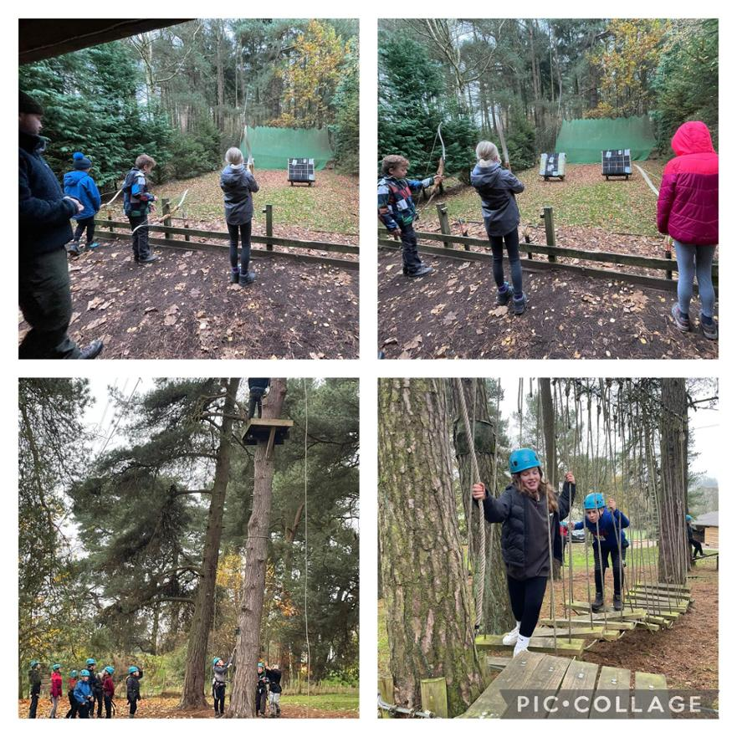
It is part of the school’s commitment to developing the whole child, supporting their physical and mental well-being. It emphasises the value of outdoor education.

What makes a great headteacher for Bubwith Community Primary School?
The views of our pupils
Someone who is kind, understanding and approachable.
Someone who is wise and shows us mutual respect.
Someone who is smart, brave and
hardworking.
What makes a great headteacher for Bubwith Community Primary School?
Someone who makes assemblies good and interesting.
Someone who finds fun ways to teach us.
Someone who looks after us and gives us hugs when we cry. (EYFS pupils)
The views of our staff
Someone who is:
A good communicator who leads from the front
A strong character who can make tough decisions when necessary- firm but fair and consistent
An approachable team player who can drive forward a collective vision
Passionate about teaching and supports the development of all staff
Cognisant of the importance of provision in EYFS and into KS1
Positive and focuses on everyone’s well-being, (pupils and staff)
Committed to an open door policy

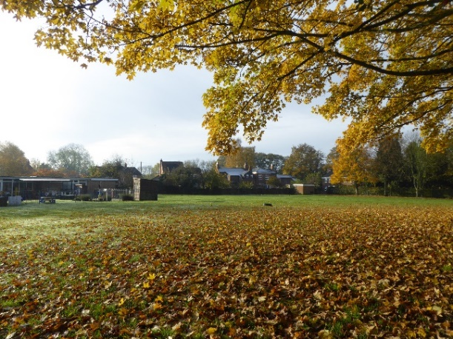
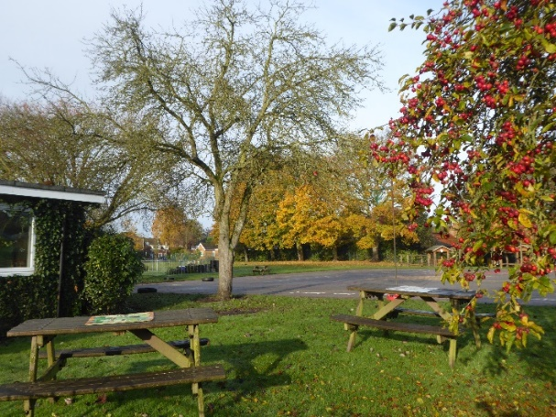

School Staff
Head teacher
- 2 Senior teachers (one on maternity leave from spring term 2025, one part time)
- 3 Full Time Teachers, 1 Part Time Teacher
- 1 nursery nurse
- One HLTA, 8 Part Time teaching assistants/ SEND support assistants
- A Business Manager, part time, and an Admin Assistant, part time
- A Cook-in-charge, 1 Catering Assistant, 3 Lunchtime Supervisors
- A caretaker and a cleaner

Headteacher of Bubwith Community Primary School

Job Description
[based on the DfE Headteachers’ Standards 2020]
Section 1: Ethics and professional conduct

Headteachers are expected to demonstrate consistently high standards of principled and professional conduct. They are expected to meet the teachers’ standards and be responsible for providing the conditions in which teachers can fulfil them.

Headteachers uphold and demonstrate the Seven Principles of Public Life at all times. Known as the Nolan principles, these form the basis of the ethical standards expected of public office holders:
- selflessness
- integrity
- objectivity
- accountability
- openness
- honesty
- leadership

Headteachers uphold public trust in school leadership and maintain high standards of ethics and behaviour. Both within and outside school, headteachers:
- build relationships rooted in mutual respect, and at all times observe proper boundaries appropriate to their professional position
- show tolerance of and respect for the rights of others, recognising differences and respecting cultural diversity within contemporary Britain
- uphold fundamental British values, including democracy, the rule of law, individual liberty and mutual respect, and tolerance of those with different faiths and beliefs
- ensure that personal beliefs are not expressed in ways which exploit their position, pupils’ vulnerability or might lead pupils to break the law

As leaders of their school community and profession, headteachers:
- serve in the best interests of the school’s pupils
- conduct themselves in a manner compatible with their influential position in society by behaving ethically, fulfilling their professional responsibilities and modelling the behaviour of a good citizen
- uphold their obligation to give account and accept responsibility
- know, understand, and act within the statutory frameworks which set out their professional duties and responsibilities
- take responsibility for their own continued professional development, engaging critically with educational research
- make a positive contribution to the wider education system

Section 2: Headteachers’ Standards

- School culture

- Establish and sustain the school’s ethos and strategic direction in partnership with those responsible for governance and through consultation with the school community
- Create a culture where pupils experience a positive and enriching school life
- Uphold ambitious educational standards which prepare pupils from all backgrounds for their next phase of education and life
- Promote positive and respectful relationships across the school community and a safe, orderly and inclusive environment where everyone feels welcome
- Ensure a culture of high staff professionalism
- Communicate and celebrate a positive image of the school
- Lead and manage change effectively
2. Teaching

- Establish and sustain high-quality, expert teaching across all subjects and phases, built on an evidence-informed understanding of effective teaching and how pupils learn
- Ensure teaching is underpinned by high levels of subject expertise and approaches which respect the distinct nature of subject disciplines
- Ensure that effective use is made of formative assessment
- Be a good or outstanding teacher and undertake a regular teaching commitment

3. Curriculum and assessment

- Ensure a broad, structured and coherent curriculum entitlement which sets out the knowledge, skills and values that will be taught, building on the CUSP curriculum that has been adopted by the school
- Establish effective curricular leadership, leading some subjects themselves and developing subject leaders with high levels of relevant expertise with access to professional networks and communities
- Ensure that all pupils are taught to read through the provision of evidence-informed approaches to reading, particularly the use of systematic synthetic phonics with Little Wandle
- Ensure valid, reliable and proportionate approaches are used when assessing pupils’ knowledge and understanding of the curriculum

4. Behaviour

- Establish and sustain high expectations of behaviour for all pupils, built upon relationships, rules and routines, which are understood clearly by all staff and pupils
- Ensure high standards of pupil behaviour and courteous conduct in accordance with the school’s behaviour policy
- Implement consistent, fair and respectful approaches to managing behaviour
- Ensure that adults within the school model and teach the behaviour of a good citizen

5. Additional and special educational needs and disabilities

- Ensure the school holds ambitious expectations for all pupils with additional and special educational needs and disabilities
- Establish and sustain culture and practices that enable pupils to access the curriculum and learn effectively
- Ensure the school works effectively in partnership with parents, carers and professionals to identify the additional needs and special educational needs and disabilities of pupils, providing support and adaptation where appropriate
- Ensure the school fulfils its statutory duties with regard to the SEND code of practice

6. Professional development

- Ensure staff have access to high-quality, sustained professional development opportunities, aligned to balance the priorities of whole-school improvement, team and individual needs
- Prioritise the professional development of staff, ensuring effective planning, delivery and evaluation which is consistent with the approaches laid out in the standard for teachers’ professional development
- Ensure that all support staff are part of a professional development system that recognises their skills and organises appropriate training opportunities
- Ensure that professional development opportunities draw on expert provision from beyond the school, as well as within it, including nationally recognised career and professional frameworks and programmes to build capacity and support succession planning
7. Organisational management

- Ensure the protection and safety of pupils and staff through effective approaches to safeguarding including in respect of e-safety, as part of the duty of care
- Prioritise and allocate financial resources appropriately, ensuring efficiency, effectiveness and probity in the use of public funds
- Consider environmental impact when making decisions about the school building, grounds and curriculum
- Ensure the effective deployment of support staff across the school (e.g. in classrooms, the office, kitchen and school maintenance)
- Ensure staff are managed well with due attention paid to workload
- Establish and oversee systems, processes and policies that enable the school to operate effectively, efficiently and sustainably
- Ensure rigorous approaches to identifying, managing and mitigating risk

8. Continuous school improvement

- Make use of effective and proportional processes of evaluation to identify and analyse complex or persistent problems and barriers which limit school effectiveness, and identify priority areas for improvement
- Develop appropriate evidence-informed strategies for improvement as part of well-targeted plans which are realistic, timely, appropriately sequenced and suited to the school’s context
- Ensure careful and effective implementation of improvement strategies, which lead to sustained school improvement over time

9. Working in partnership

- Forge constructive relationships beyond the school, working in partnership with parents, carers and the local community including SHAC, the Treehouse Nursery, FOBS, the parish council and the village parent and toddler group
- Build links with national and international groups, developing pupils’ global awareness
- Commit the school to work successfully with other schools and educational organisations in a climate of mutual challenge and support
- Establish and maintain working relationships with fellow professionals and colleagues across other public services to improve educational outcomes for all pupils

10. Governance and accountability

- Understand and welcome the role of an effective governing body, upholding their obligation to give account and accept responsibility
- Establish and sustain a professional working relationship with governors, facilitating class and subject link visits, attending committee meetings and providing the necessary reports, data and planning documents
- Ensure that staff know and understand their professional responsibilities and are held to account
- Ensure the school operates effectively and efficiently within the required regulatory frameworks and meets all statutory duties

Headteacher of Bubwith Community Primary School

Person Specification

 | The application should show the extent to which the applicant can demonstrate success in the following areas. | E: essential  D: desirable | A: application form  I: interview process  R: reference
Domain one:  School Culture | Communicating the school’s vision compellingly  Driving or contributing to the strategic leadership of the school and empowering pupils and staff to excel  Demonstrating positive personal behaviour and enthusiasm in their relationships and attitudes towards their pupils and staff, parents, governors and members of the local community  Leading by example – with integrity, creativity, reflection, resilience, and clarity – drawing on their own scholarship, expertise and skills, and that of those around them  Collaborating, delegating, monitoring and reviewing effectively  Promoting extra-curricular activities | E  E  E  E  E  E | I  I  A & I  A & I  A & I  A & I
Domain two:  Curriculum and Teaching | Promoting ambitious standards for pupils across the school, overcoming disadvantages and advancing equality, instilling a strong sense of accountability in teaching staff for the impact of their work on pupils’ outcomes  Foster a caring, well-structured and creative learning environment, including use of the outdoor space, where pupils are confident to ask questions, use initiative and reflect on their own skills and progress  Creating an ethos within which all staff are motivated and supported to develop their own skills and subject knowledge, and to support each other  Securing high quality teaching through analytical understanding of how pupils learn and of the core features of successful classroom practice and curriculum design leading to rich curriculum opportunities and pupils’ well-being  Holding staff to account for their professional conduct and practice | E  E  D  E  D | A & I  A & I  I  A & I  I
Domain three:  Organisational Effectiveness | Providing a safe, calm and well-ordered environment for pupils and staff, focused on safeguarding pupils and  developing their exemplary behaviour in school and in the wider society  Carrying out rigorous, fair and transparent teacher performance management, addressing any under-performance and supporting staff to improve and work towards excellent practice  Creating a peer support culture so that the best teachers share practice and raise the overall standard of teaching across the school  Reviewing and revising whole school policies  Exercising strategic financial planning in the best interests of pupils’ achievements and the school’s sustainability | E  E  D  E  D | A & I  A & I  A & I  A & I  A & I
Domain four:  The self-improving school system | Inspiring and influencing others – within and beyond school – to believe in the fundamental importance of education in young people’s lives and to promote the value of education  Shaping the current and future quality of the teaching profession through high quality training and sustained professional development for individual teachers and/or all staff | D  D | I  A & I
In addition the interview panel will consider evidence for: | Qualified teacher status  Other relevant qualifications, including a degree  Relevant and recent CPD  Successful leadership in a senior role in their current school with evidence of focused and measureable outcomes  Experience of class teaching in both key stage 1 and key stage 2 and of teaching EYFS pupils | E  E  E  E  D | A  A  A & I  A, I & R  A & R

