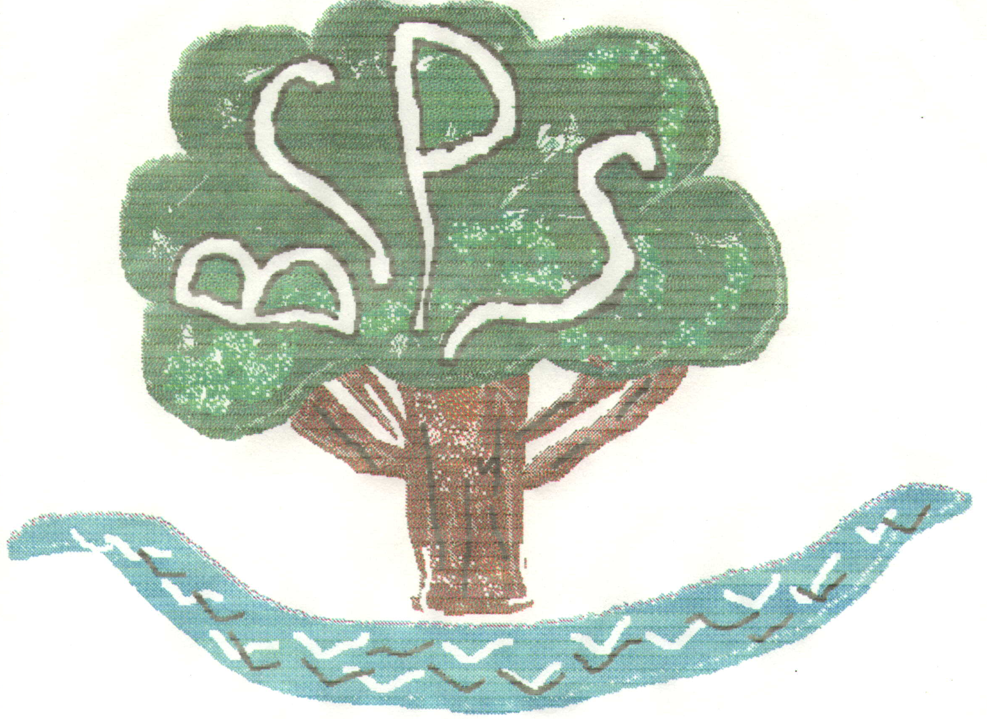
Bubwith Community Primary School

Church Street

Bubwith

Selby

YO8 6LW

Telephone / Fax: (01757) 288261

30th September 2015

Dear

Headteacher Recruitment Update

I wanted to write to let you know that prospective candidates for the post of permanent Headteacher for our school were shortlisted last week and have been invited to attend an interview day, on site, next Monday 5th October from 8.15am until 4.00pm. This type of interview day is standard practice for the post and will give the governing body and our school improvement advisor, Mrs J Rawling, an opportunity to see the candidates demonstrate their skills, qualities and style of leadership via a variety of tasks throughout the day.

The panel of governors will be Mrs Jo Menneer, Mrs Joanna Ainsley, Mrs Fran Ward, Mrs Liz Bell and myself.

Candidates will be using the quiet room, library and Mrs Marshall’s office for some of the tasks but are encouraged to move freely around the school. This will mean that candidates could pop into classrooms, enjoy our display boards, make notes to assist with their tasks and talk with the children at playtimes and lunchtime. Governors and candidates will be having a school lunch with the children too.

As part of the process it is usual to offer candidates the chance to meet with those governors not involved in the interview process and staff at the end of the day. We will be holding a brief meet and greet session in the library at 3.45pm until 4.15pm and would be very grateful if you could come.

I really do appreciate that this is a challenging day for everyone and want to take this opportunity to thank you in advance for your help and support. Special thanks goes to Miss Bailiss, Mrs Wiles, Miss Moore, Mrs Deighton and Mrs Steeles for accommodating all our requests within such a tight timescale.

I will, of course, let you know our decision as soon as possible. Thank you again.

Yours sincerely

Sue Bakes
Chair of Governors

