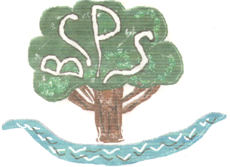
Headteacher Interviews with School Council
Name of Candidate: …………………………………………………………….
Welcome to Bubwith. I am Francesco and I am in Year 6. We are very pleased that you have joined us today. We are going to ask you some questions but first we are going to introduce ourselves (everyone says their names and their year group).
- Question 1 FLORA & ABI

FLORA - Why do you want to become our Head teacher?
ABI - What would you do to improve our school if you became our Head teacher?

- Question 2 ISABELLA & EMMA

ISABELLA - Have you ever been a Head teacher at any other school?
EMMA - How much experience do you have of teaching?

- Question 3 OLIVER & ROBYN

OLIVER - Do you have a favourite minion?
ROBYN - What’s your favourite film?

- Question 4 BENJAMIN & FRANCESCO

BENJAMIN - What’s your favourite thing about our school?
FRANCESCO - What are your main interests?

- Question 5 RUBY & JAMIE

RUBY - Are you shy when you do assemblies?
JAMIE - What’s your favourite school dinner and do you like beans?

- Question 6 LIAM

LIAM - Do you like football? Can you get us a proper ball to play with and what football team do you support?

SCHOOL COUNCIL OPINIONS.

Did the candidate answer your questions? How did they answer them?
What did you think about their answers?
(To be discussed by School Council and written by Francesco).

